Database Requirements Document (DRD)

Declaration
This project is an academic project developed by me (Amr Gamal) as part of my university studies. All requirements, documentation, and design artifacts (BRD, FRD, Use Cases, and User stories) were created independently for learning and portfolio purposes. The system is a simulated ATM system (Bank MASR ATM System) and is not associated with any real bank or financial institution.

Project Information
Item | Value
Project Name | Bank MASR ATM System
Document Type | Database Requirements Document
Version | 1.0
Author | Amr Gamal
Date | June 2026

1. Purpose
This document defines the database requirements, entities, relationships, constraints, and business rules for the Bank MASR ATM System.
The database is designed to support:
- User Authentication
- Account Management
- Transaction Processing
- Fund Transfers
- Receipt Generation

2. Database Scope
The database shall store and manage:
- Customer information
- Bank accounts
- Account balances
- Financial transactions
- Fund transfers
- Transaction receipts
The database shall not:
- Create customer accounts automatically
- Manage ATM hardware
- Manage bank employees
Customer accounts are created and maintained by the bank.

3.ERD
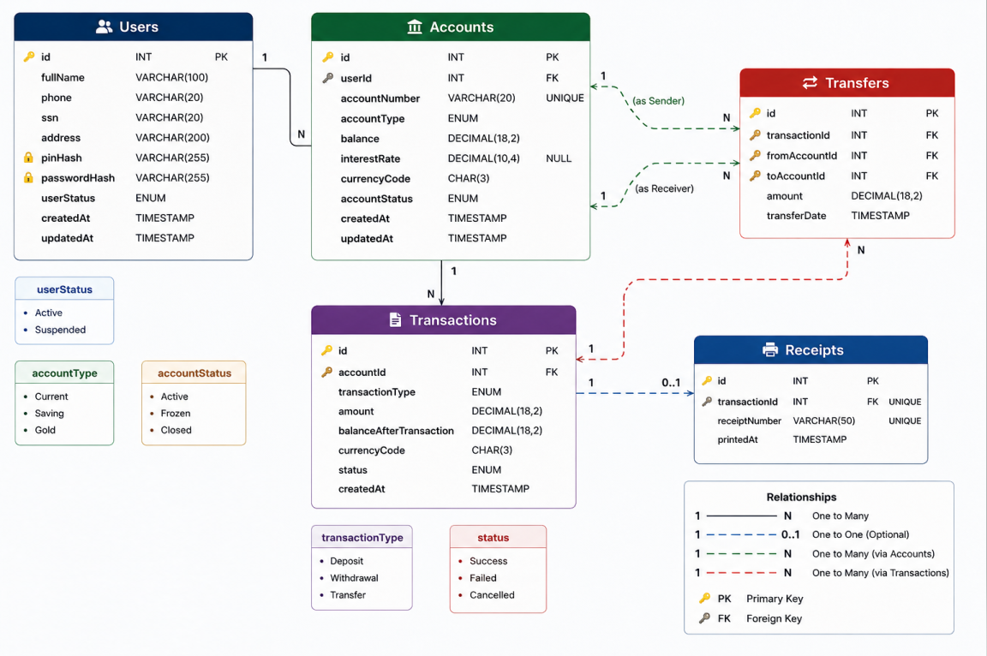

4. Database Entities Overview
Entity | Description
Users | Stores customer information
Accounts | Stores customer bank accounts
Transactions | Stores all account activities
Transfers | Stores transfer-specific information
Receipts | Stores printed receipt information

5. Entity Specifications
4.1 Users
Description
Stores customer information used for ATM authentication and account ownership.
Table
Users
Attributes
Column | Type | Constraint
id | INT | PK
fullName | VARCHAR(100) | NOT NULL
phone | VARCHAR(20) | NOT NULL
ssn | VARCHAR(20) | UNIQUE
address | VARCHAR(200) | NULL
pinHash | VARCHAR(255) | NOT NULL
passwordHash | VARCHAR(255) | NOT NULL
userStatus | ENUM | NOT NULL
createdAt | TIMESTAMP | NOT NULL
updatedAt | TIMESTAMP | NOT NULL

Business Rules
ID | Rule
DB-BR-001 | Each user shall have a unique ID
DB-BR-002 | PIN shall be stored as hashed value
DB-BR-003 | Password shall be stored as hashed value
DB-BR-004 | User status shall be Active or Suspended

4.2 Accounts
Description
Stores all customer bank accounts.
Table
Accounts
Attributes
Column | Type | Constraint
id | INT | PK
userId | INT | FK
accountNumber | VARCHAR(20) | UNIQUE
accountType | ENUM | NOT NULL
balance | DECIMAL(18,2) | NOT NULL
interestRate | DECIMAL(10,4) | NULL
currencyCode | CHAR(3) | NOT NULL
accountStatus | ENUM | NOT NULL
createdAt | TIMESTAMP | NOT NULL
updatedAt | TIMESTAMP | NOT NULL

Business Rules
ID | Rule
DB-BR-005 | Each account shall belong to one user
DB-BR-006 | A user may own 1 to 3 accounts
DB-BR-007 | Account number shall be unique
DB-BR-008 | Account type shall be Current, Saving, or Gold
DB-BR-009 | Balance shall never be negative
DB-BR-010 | Account status shall be Active, Frozen, or Closed

4.3 Transactions
Description
Stores all account financial operations.
Table
Transactions
Attributes
Column | Type | Constraint
id | INT | PK
accountId | INT | FK
transactionType | ENUM | NOT NULL
amount | DECIMAL(18,2) | NOT NULL
balanceAfterTransaction | DECIMAL(18,2) | NOT NULL
currencyCode | CHAR(3) | NOT NULL
status | ENUM | NOT NULL
createdAt | TIMESTAMP | NOT NULL

Business Rules
ID | Rule
DB-BR-011 | Every transaction shall belong to one account
DB-BR-012 | Transaction amount shall be greater than zero
DB-BR-013 | Transaction type shall be Deposit, Withdrawal, or Transfer
DB-BR-014 | Transaction status shall be Success, Failed, or Cancelled
DB-BR-015 | System shall store balance after each transaction

4.4 Transfers
Description
Stores transfer details between accounts.
Table
Transfers
Attributes
Column | Type | Constraint
id | INT | PK
transactionId | INT | FK
fromAccountId | INT | FK
toAccountId | INT | FK
amount | DECIMAL(18,2) | NOT NULL
transferDate | TIMESTAMP | NOT NULL

Business Rules
ID | Rule
DB-BR-016 | Sender account must exist
DB-BR-017 | Receiver account must exist
DB-BR-018 | Sender account balance must be sufficient
DB-BR-019 | Transfer amount shall be greater than zero
DB-BR-020 | Transfer record shall be linked to a transaction

4.5 Receipts
Description
Stores printed transaction receipts.
Table
Receipts
Attributes
Column | Type | Constraint
id | INT | PK
transactionId | INT | FK UNIQUE
receiptNumber | VARCHAR(50) | UNIQUE
printedAt | TIMESTAMP | NOT NULL

Business Rules
ID | Rule
DB-BR-021 | Receipt shall belong to one transaction
DB-BR-022 | Receipt number shall be unique
DB-BR-023 | Receipt printing is optional

5. Relationship Requirements
ID | Relationship
DB-RL-001 | One User can own many Accounts
DB-RL-002 | One Account belongs to one User
DB-RL-003 | One Account can have many Transactions
DB-RL-004 | One Transaction belongs to one Account
DB-RL-005 | One Transaction may have one Receipt
DB-RL-006 | One Receipt belongs to one Transaction
DB-RL-007 | One Account can be sender in many Transfers
DB-RL-008 | One Account can be receiver in many Transfers

7. Data Integrity Requirements
ID | Requirement
DIR-001 | All primary keys shall be unique
DIR-002 | Foreign key constraints shall be enforced
DIR-003 | Referential integrity shall be maintained
DIR-004 | Account balances shall not become negative
DIR-005 | Deleted users shall not orphan account records

8. Security Requirements
ID | Requirement
DSR-001 | Passwords shall be stored as hashes
DSR-002 | PINs shall be stored as hashes
DSR-003 | Sensitive customer data shall be protected
DSR-004 | Unauthorized access shall be prevented

9. Performance Requirements
ID | Requirement
DPR-001 | Account lookup shall execute within 3 seconds
DPR-002 | Transaction history retrieval shall execute within 3 seconds
DPR-003 | Transfer processing shall execute within 3 seconds

10. Assumptions
ID | Assumption
AS-001 | Accounts are created by the bank
AS-002 | ATM system cannot create accounts
AS-003 | A user may have between 1 and 3 accounts
AS-004 | Current Account is mandatory
AS-005 | Saving and Gold Accounts are optional

